**Lab Assignment 10**

This web application designed using node js when the server runs in the local host and we run the web application on the server. This is a Mash up of two web services one is face detection and the other is Tone analyzer.

**Wire Frames:**

**Index Page:**

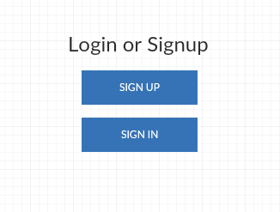

**Registration Page:**

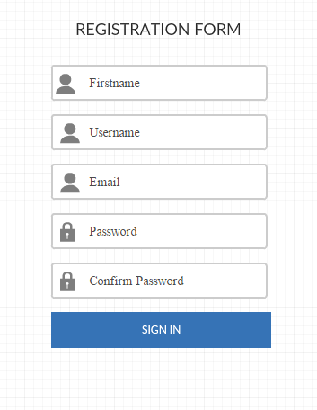

**Registration Success Page:**

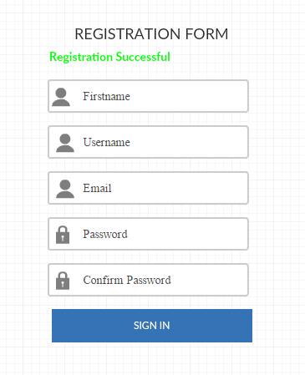

**Registration Failure Page:**

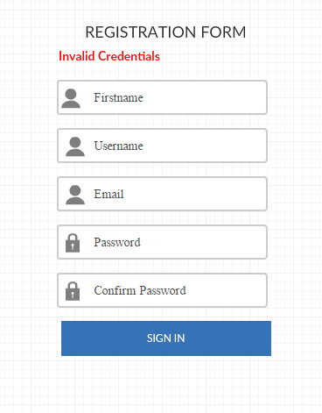

**Login Page:**

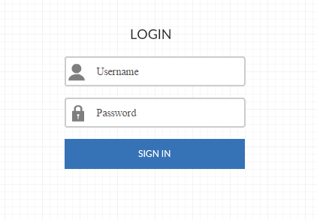

**Login Failure Page:**

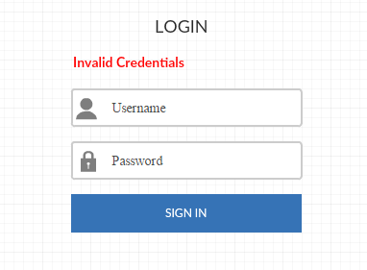

**Home Page:**

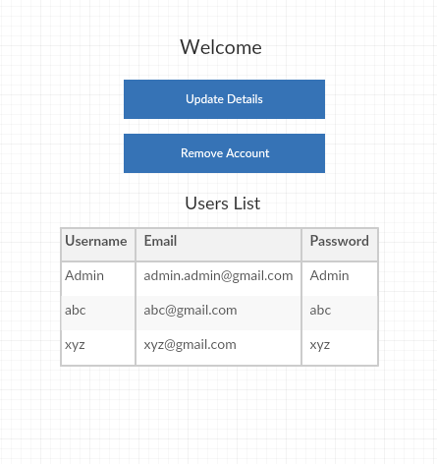

**Update Page:**

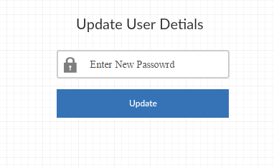

**Update Success Page:**

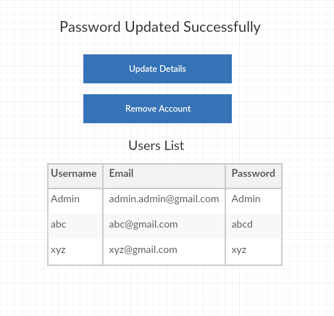

**Delete Success Page:**

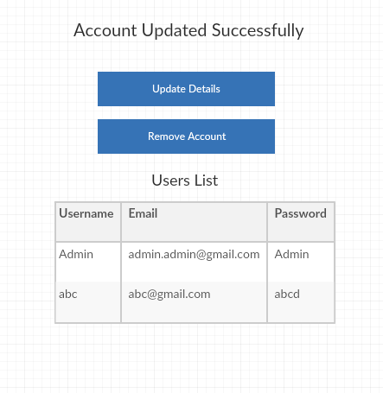

**Web Application Pages:**

**Index Page:**

This is the index page of the application which contains two buttons “Sign In” and “Sign Up” when clicking on the buttons it will navigate to the Login and Registration pages respectively.

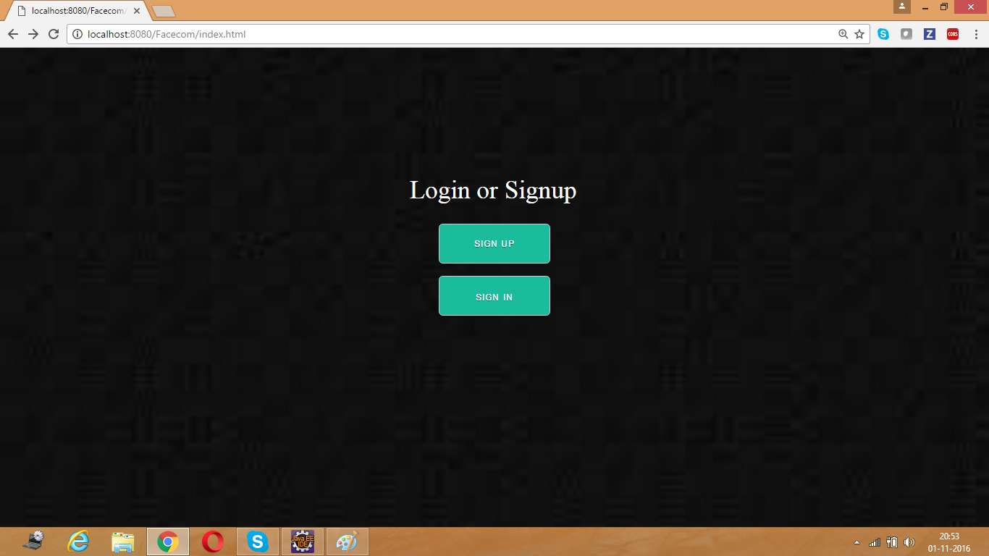

**Registration Page:**

This is the registration page of the application. It contains the fields like First name, Username, Email, Password and Confirm Password after entering the values in these fields it will the data into the Mongo DB.

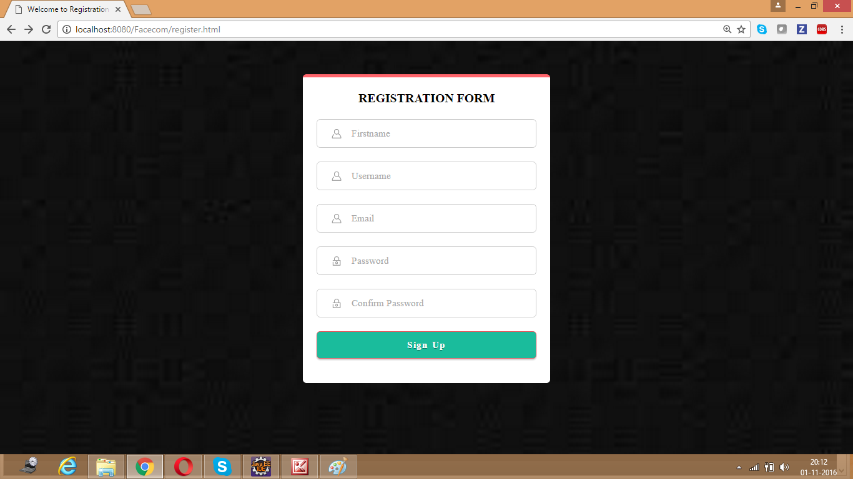

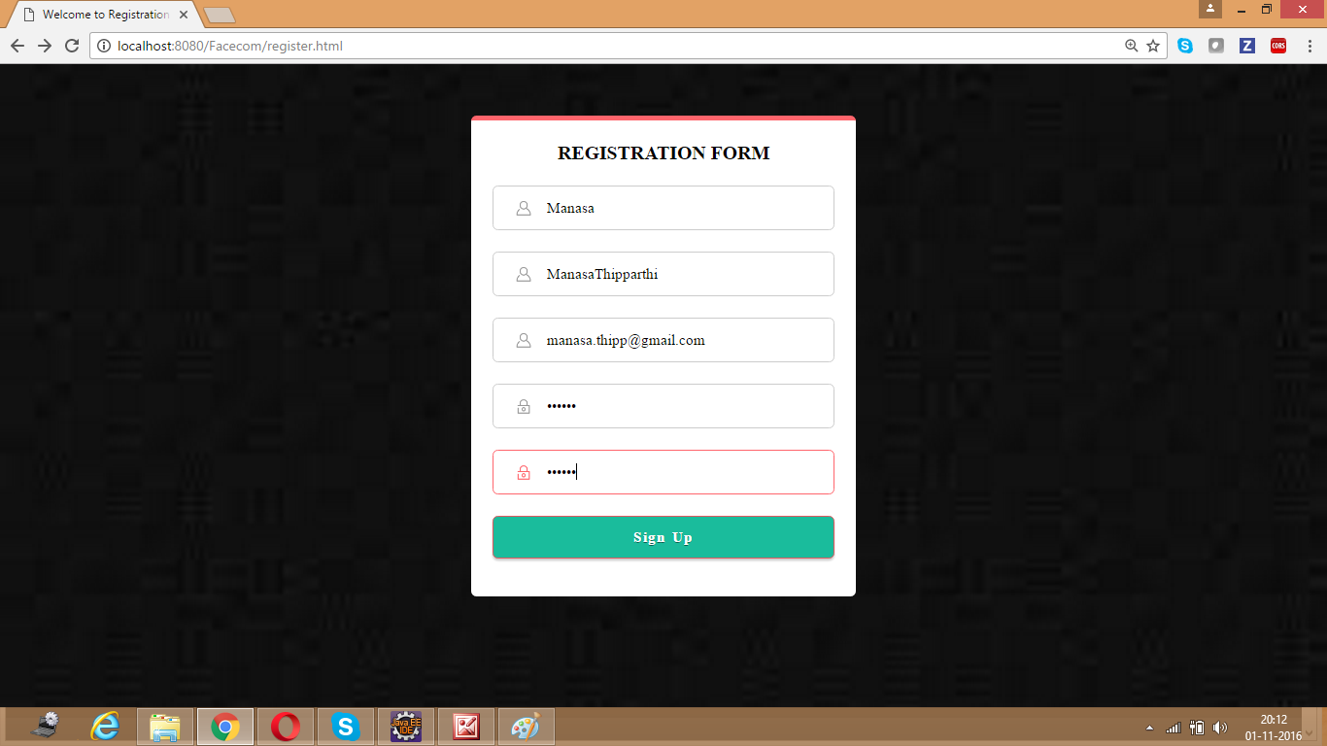

**Registration Success Page:**

After the registration is successful it will display a message that the “Registration Successful”.

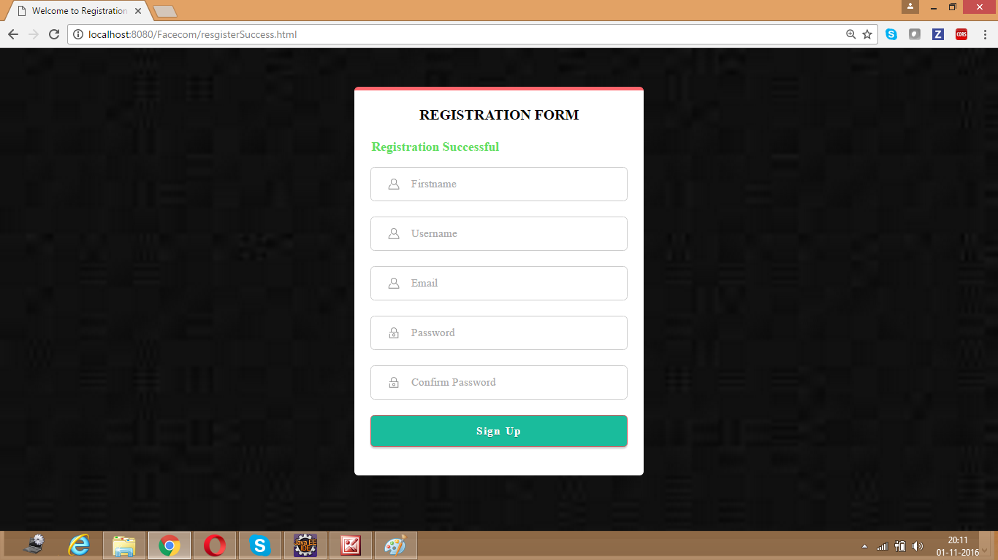

**Mongo DB Registration Success Page:**

This is the MLab page where we can find the user details after successful registration.

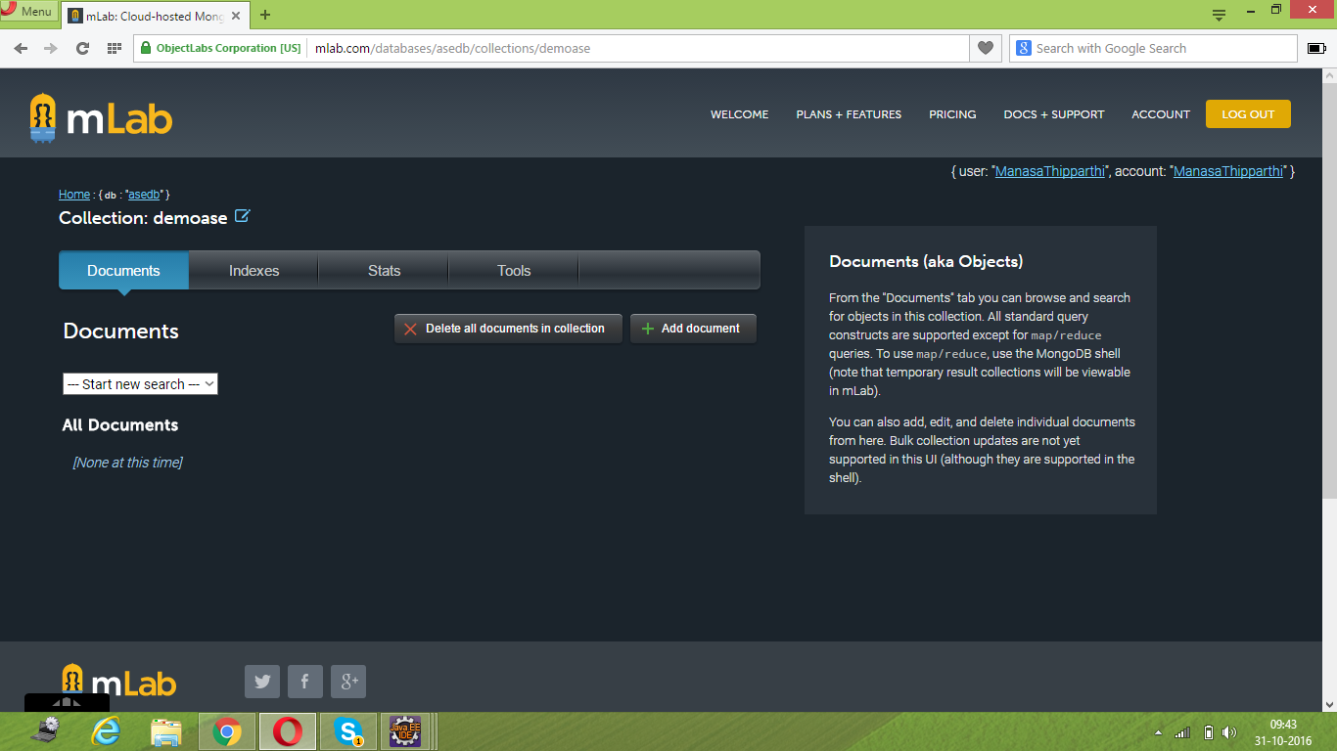

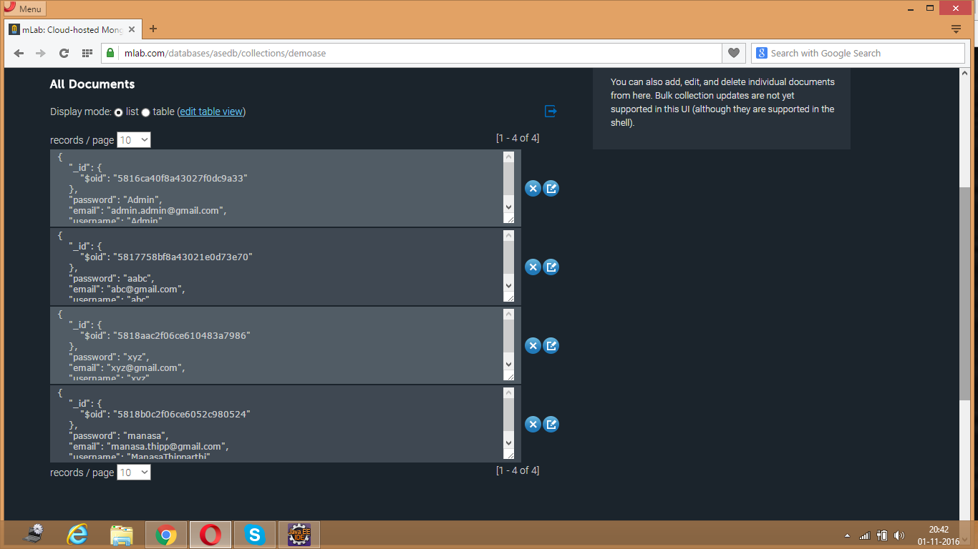

**Login Page:**

This is the Login page of the application which contains two fields namely Username and Password when you enter the values in the fields and click “Sign In” button. It will check the values in the Mongo DB and if the user with the values exists then the login is successful.

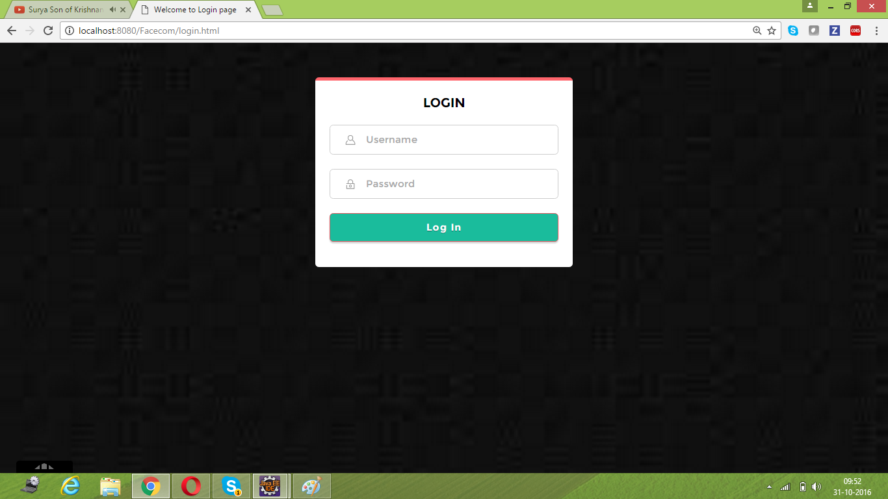

**Login Failure Page:**

If the user data is not matched with any of the values in the Mongo Db then it will display a message that “Login Failure”.

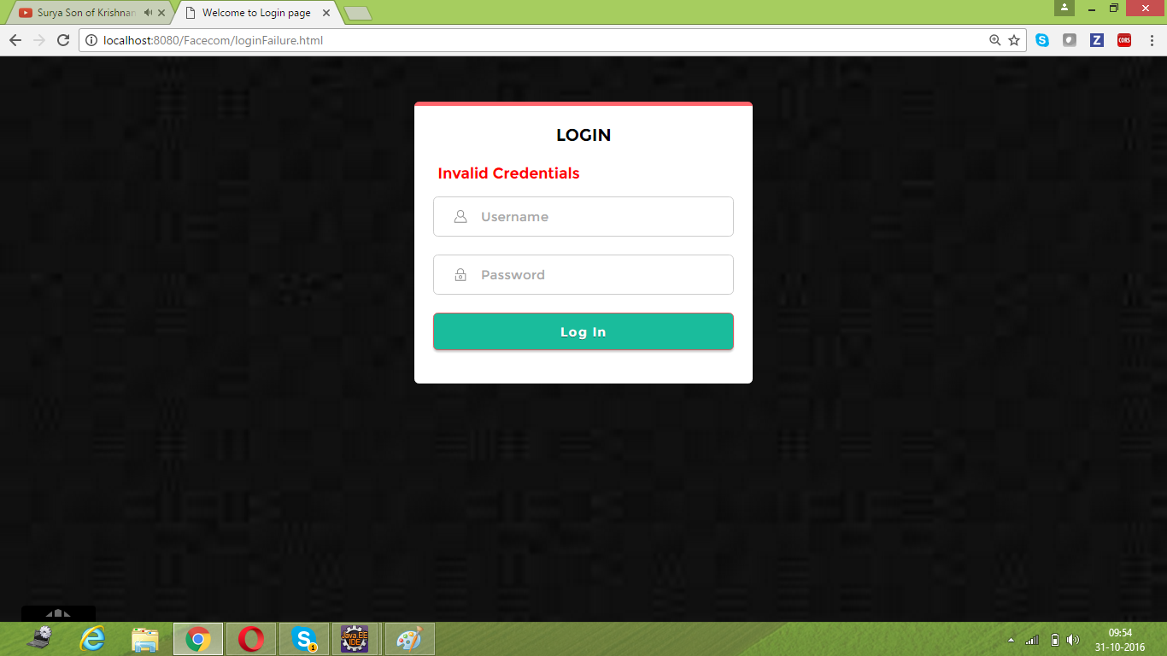

**Mongo DB Data Page:**



**Home Page:**

Once the Login is successful then it will be directed to Home Page where you can find all the users list and also options to update and delete current users account details.

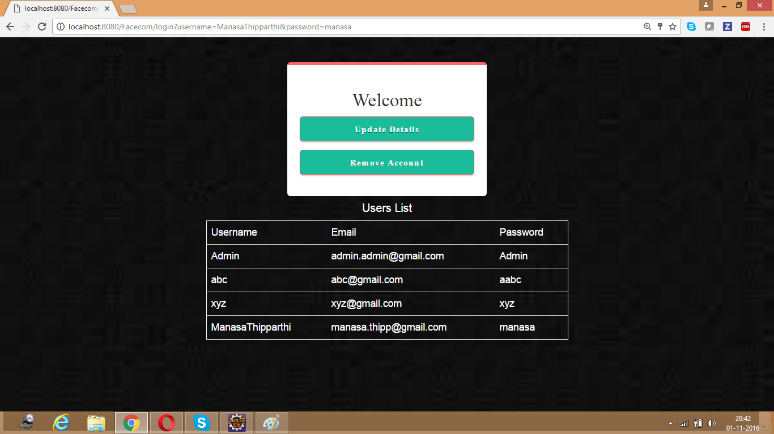

**Update Page:**

This is the Update Page of the application which contains a field to change the password. Once you enter the password to be changed and then click “Update” then will update the password in the Mongo DB and directs to Home page showing “Password Updated Successfully”.

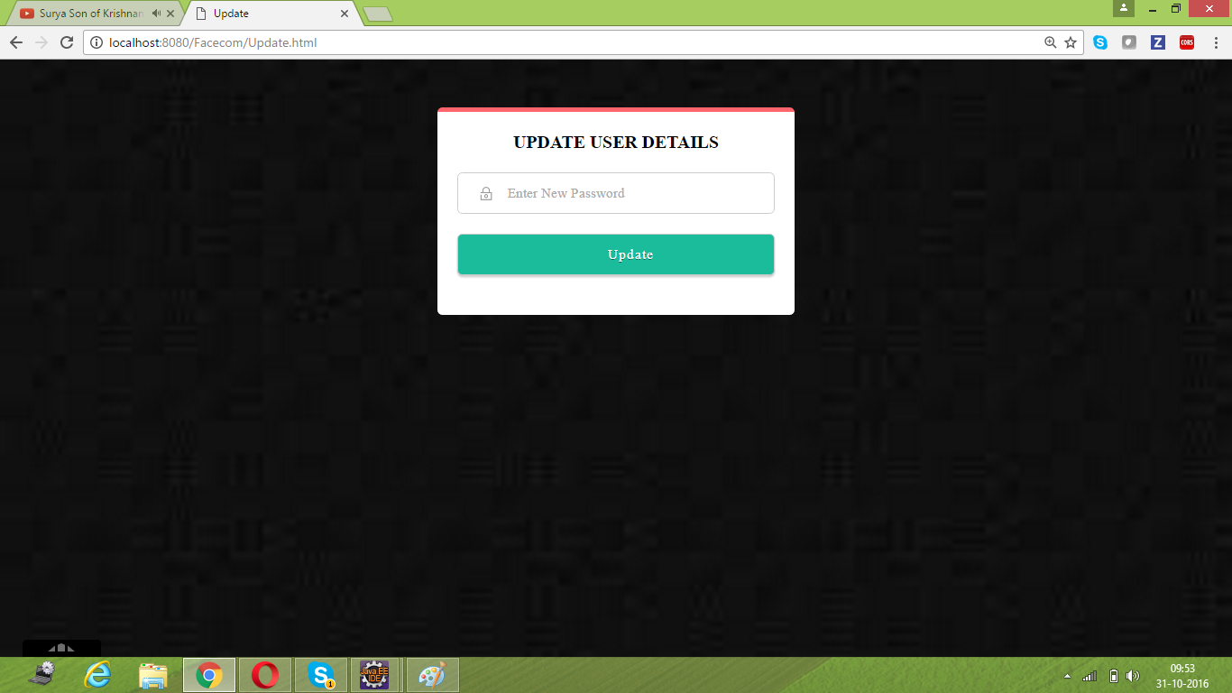

**Update Success Page:**

Once the password is updated successfully in the Mongo DB it will direct to Home page showing message “Password Updated Successfully”.

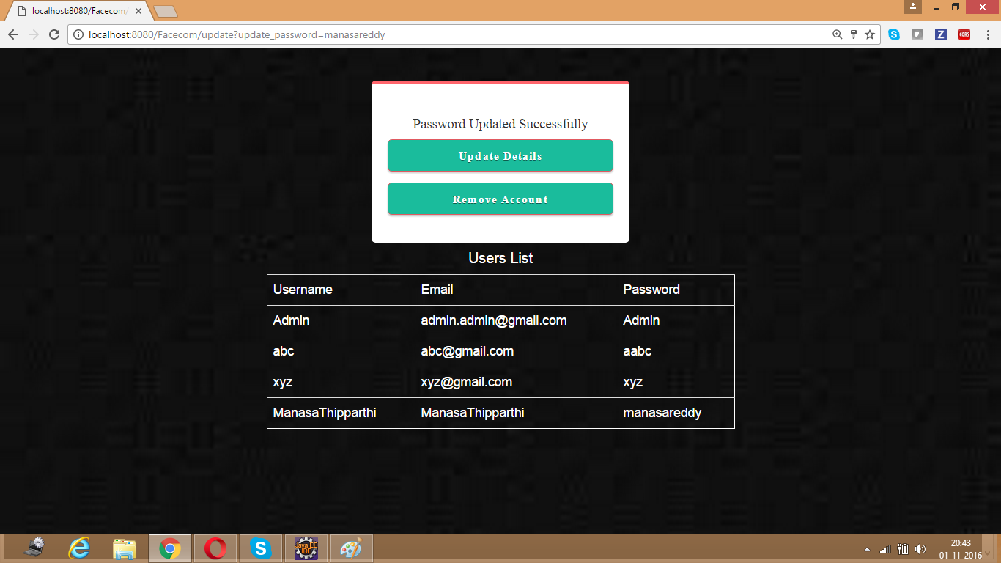

**Mongo DB Update Success Page:**

This is the Mongo DB page where you can find the password has been updated successfully.

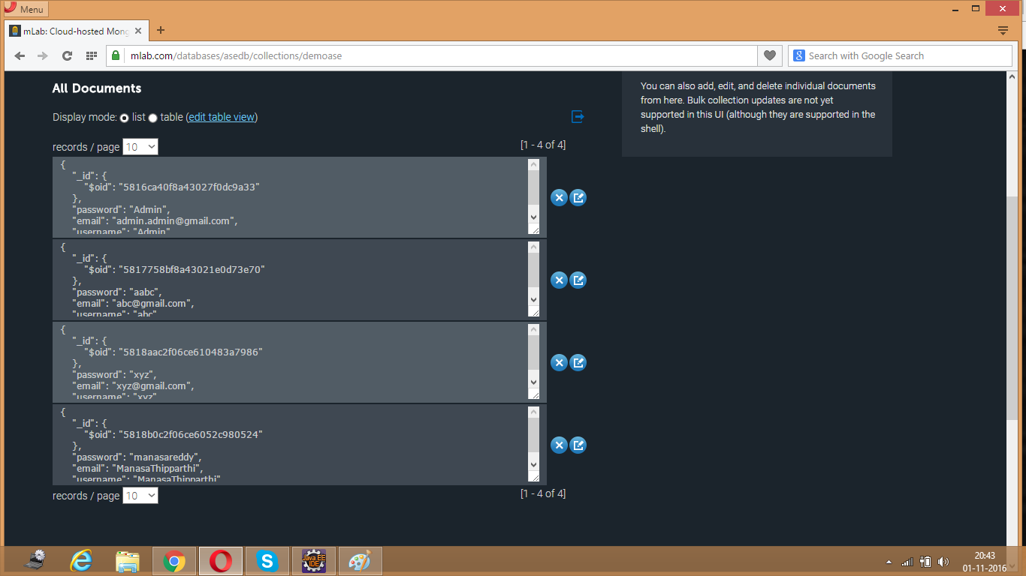

**Delete Page:**

Once you click the Remove account then it will delete current account from the Mongo DB.



**Delete Success Page:**

Once the user account has been successfully deleted from the Mongo DB it will direct to the Home page stating that “Account Deleted Successfully”.

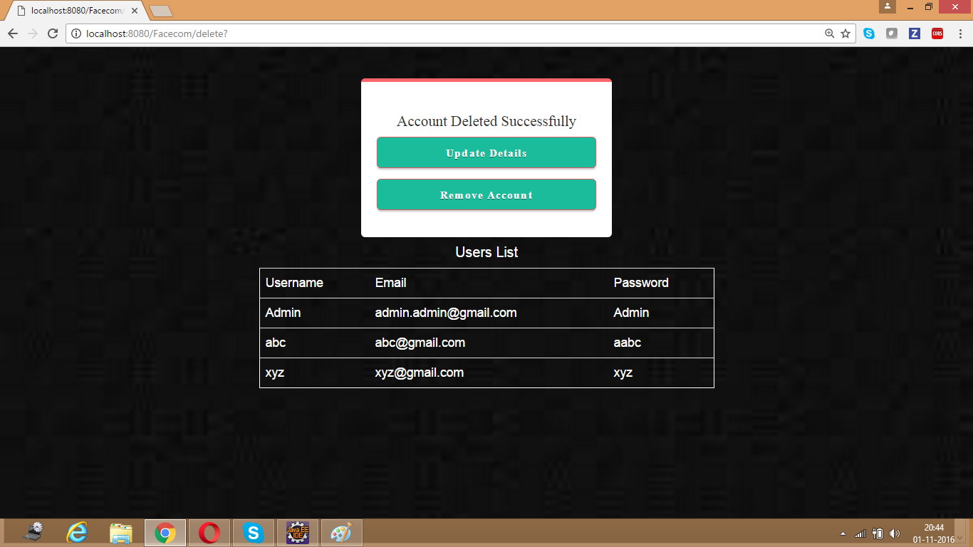

**Mongo DB Delete Success Page:**

This is the Mongo DB page where you find the user account has been deleted successfully and you cannot find the user details in the documents list.

